**Objective of the Day:**

* Show 2 images and combine them essentially
  + 1 image is a face
  + 1 image is a texture
  + Can control the amount of overlap between the two
* Texture superimposed on the two triangles
* Because images are being used, he uses an open source library called SOIL
  + It is only for opening and manipulating images
  + Examples in class are only using open source libraries
  + SOIL is integrated in the Linux distribution itself

**Discussion of Code:**

* Mix_value is 0.2f ← Very important to note
* Initial set up is same as before in order to open the GL Window
  + All the code from Initial to the shader is essentially the same
  + Shader is changed a little bit
* Generate 2 texture tabs that we will later bind to the images on the triangle
* Generate 1st texture:
  + We do GenTextures: assigns texture to 1st image
  + Textures are 2D because the images are 2D
  + How to wrap the texture around the edges:
  + How to have the texture when there is no direct mapping
  + We are opening the image and doing the width and height of the image and having it load as an RGB
    - Take the image and convert into a texture map that we will later use
    - GL_TEXTURE_2D for the image
    - glGenerateMipMap → A mipmap is a hierarchical image that you can use at run time that determine how to run and load
  + After you will free image
  + After image is free then we will unbind the image
  + Bind the texture, specify the parameters, then unbind the texture
* Same code applies as is for the 2nd texture (the face)
* Specify how to map the images on the geometry
  + We have the positions and colors as previously done for each vertex
  + Now we do the textures for that as well
  + Indices array remains the same as we have 2 triangles
  + Buffer object remains the same except for the specification for the attributes
    - All of type float, and 3rd parameter is false, 4th parameter is of 8 because we need 8 floating point values before going onto the next vertex
    - Position starts at 0, 3 floating point values
      * Color starts at 1, 3 floating point values
      * Texture starts at 2, 2 floating point values
  + The Display Loop
    - Use our shader program
    - Bind the texture
      * activeTexture(GL_TEXTURE0)
        + First texture
    - Pass the mix_value to the shader
      * Used to change its behavior on how to display the data
* Shader.vs
  + Layout
    - Position vector3
    - Color vector3
    - Texture vector2
  + Output
    - Color
    - Texture coordinate
  + For texture coordinate, we do x, and then 1 - y coordinate
* Shader.frag
  + Input:
    - Our_color //output of shader.vs
    - Texture coordinate //output of shader.vs
  + Output:
    - Color vector4
  + Uniform
    - Data type to allow the shader to communicate with the data
    - Lets the GPU talk directly to the main program without sending an array object
  + For our texture 1, we do the TexCoord
  + For our texture 2, we do 1-TexCoord.x, TexCoord.y
  + Mix_value changes based off the input from the keyboard
* Window Behavior
  + Escape key remains the same
  + Up key:
    - We will add 1
    - If goes at 1 we will stay at one
  + Down key
    - We will subtract 1
    - If goes below 0, we will stay at 0

**Elements of a Circuit:**

* LED:
  + had the anode → connect to positive
  + Cathode → connect to negative
  + 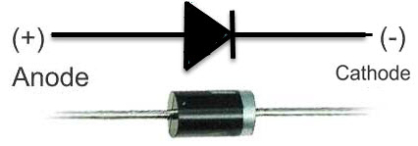
* Resistor:
  + 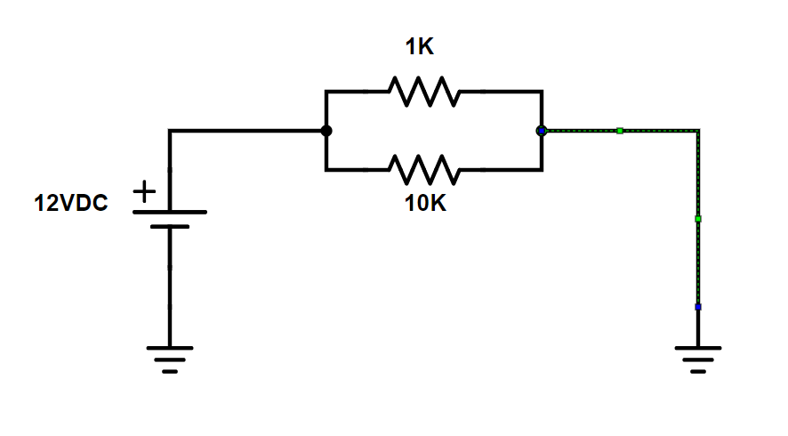
* Transistor:
  + 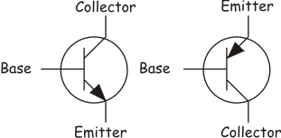
  + If the base is off, no current can flow
  + The current flows from top to bottom
  + Max voltage supply in Arduino is 5V
  + If you want a larger voltage supply, then use a transistor
    - It will supply a low current through the transistor
    - Collector can be anything you want
      * Outer source, not from the Arduino
    - Main goal: Have large currents without frying the arduino
* Capacitor:
  + 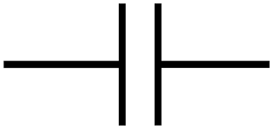
  + 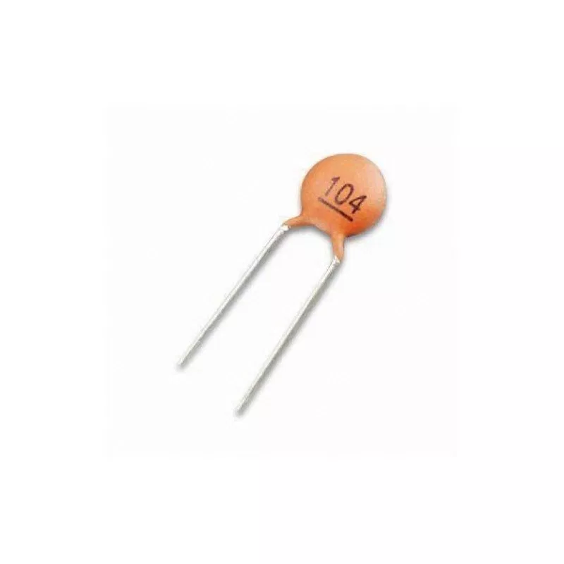
  + 2 Kinds of Capacitors that come with the kit, we will use the smaller one
    - 100nF is the one we will use
  + Slow down fluctuations in your circuit
  + Acts as a temporary power source
  + Purpose is to hold charge
    - Smaller capacitors hold smaller amount of charge
    - Larger capacitors hold larger amount of charge
* Switch
  + 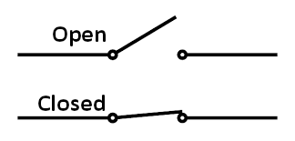
  + Four Legs with a Button on top that will close the circuit when pressed
  + Best way to put the switch on the breadboard is put it on the divider
    - May need to stretch the legs out a bit to fit

**Assembly of the Circuit on the BreadBoard:**

* Most of the time when operating with small elements it is best to use forceps
* Put the capacitor to the left of the switch
  + 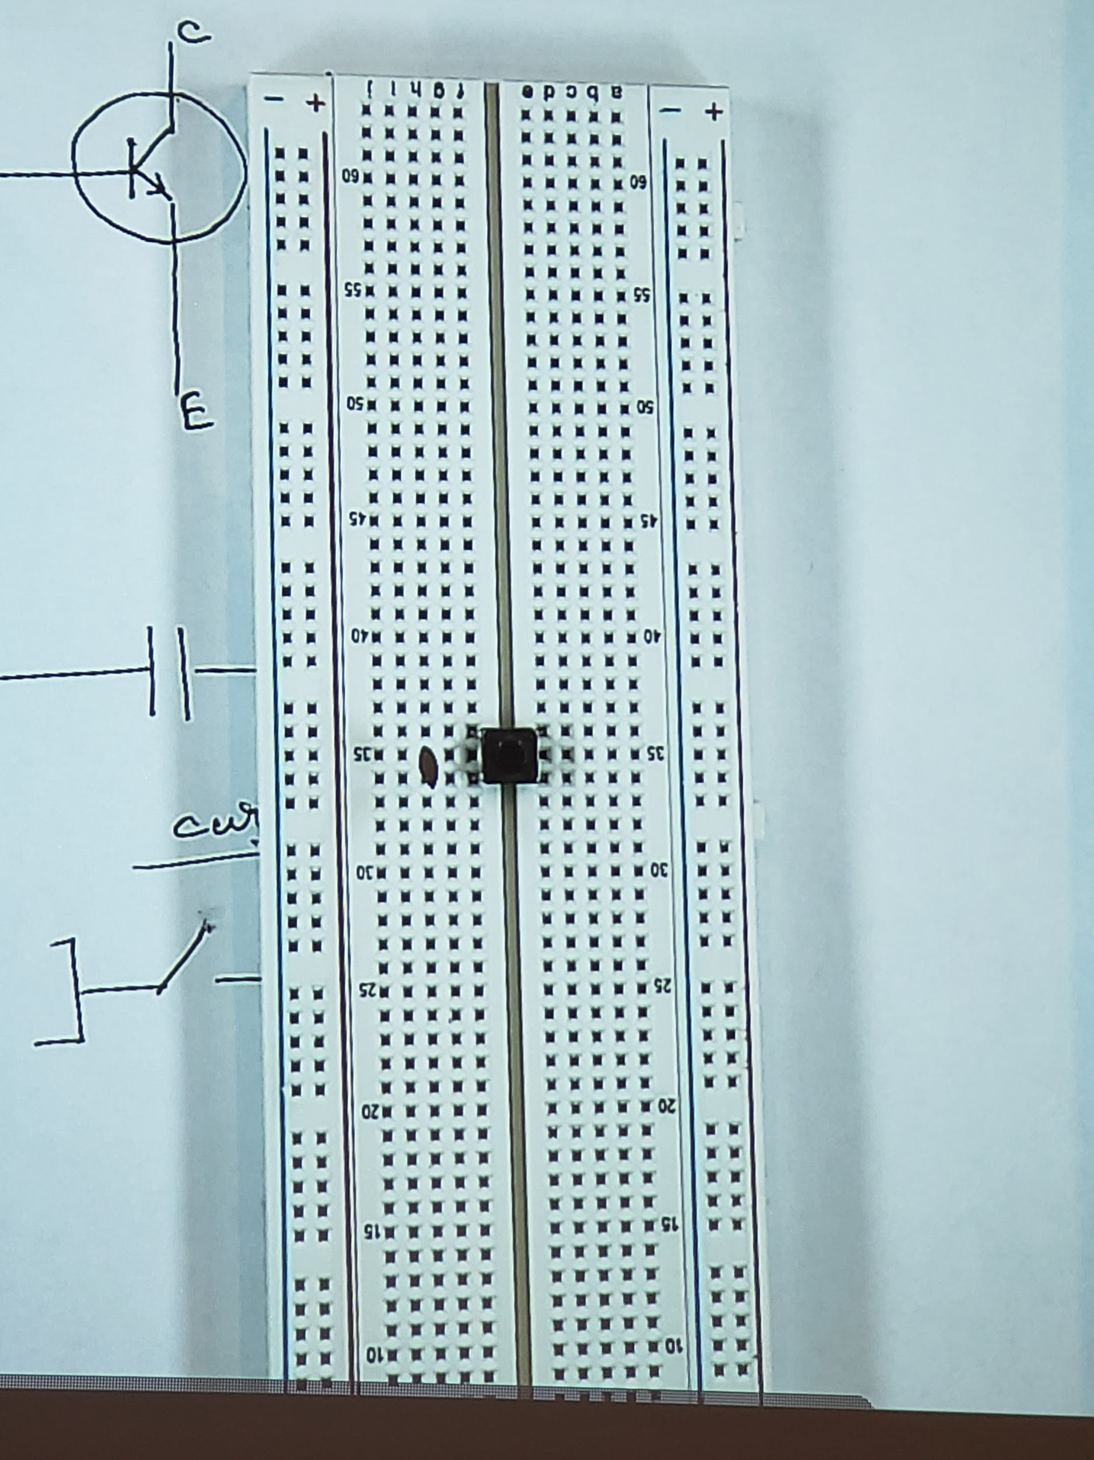
* Connect the ground supply to the same row as the switch(opposite of the board)
  + 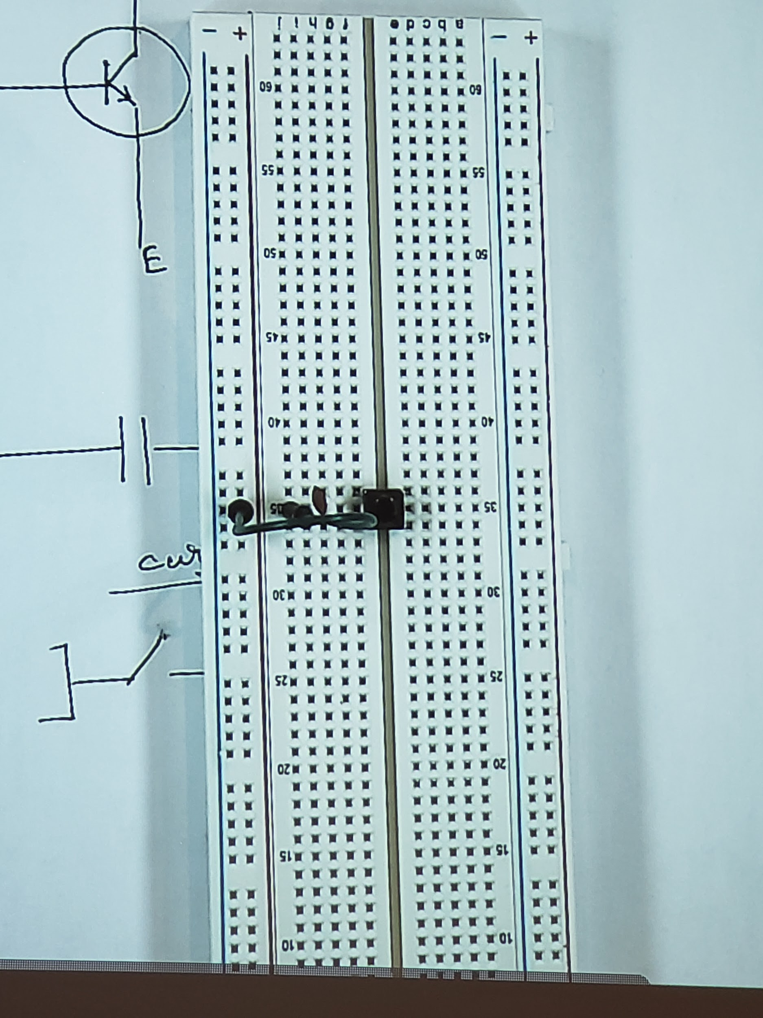
* Put the Resistor in parallel to the capacitor
  + 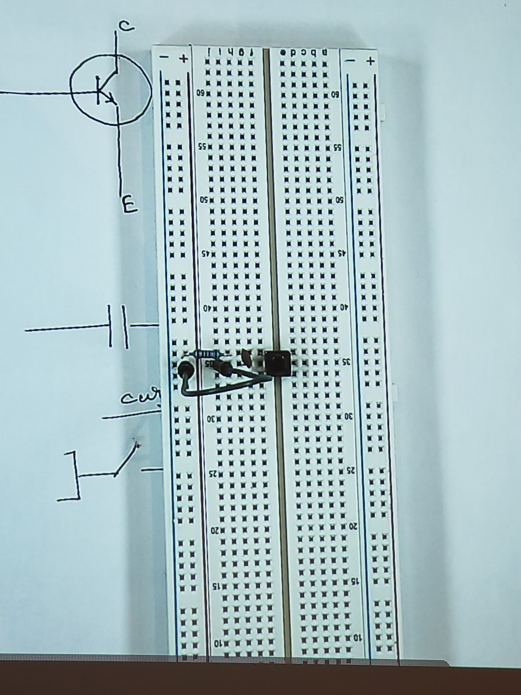
* Connect the other leg of the switch to power supply(opposite of the board)
  + 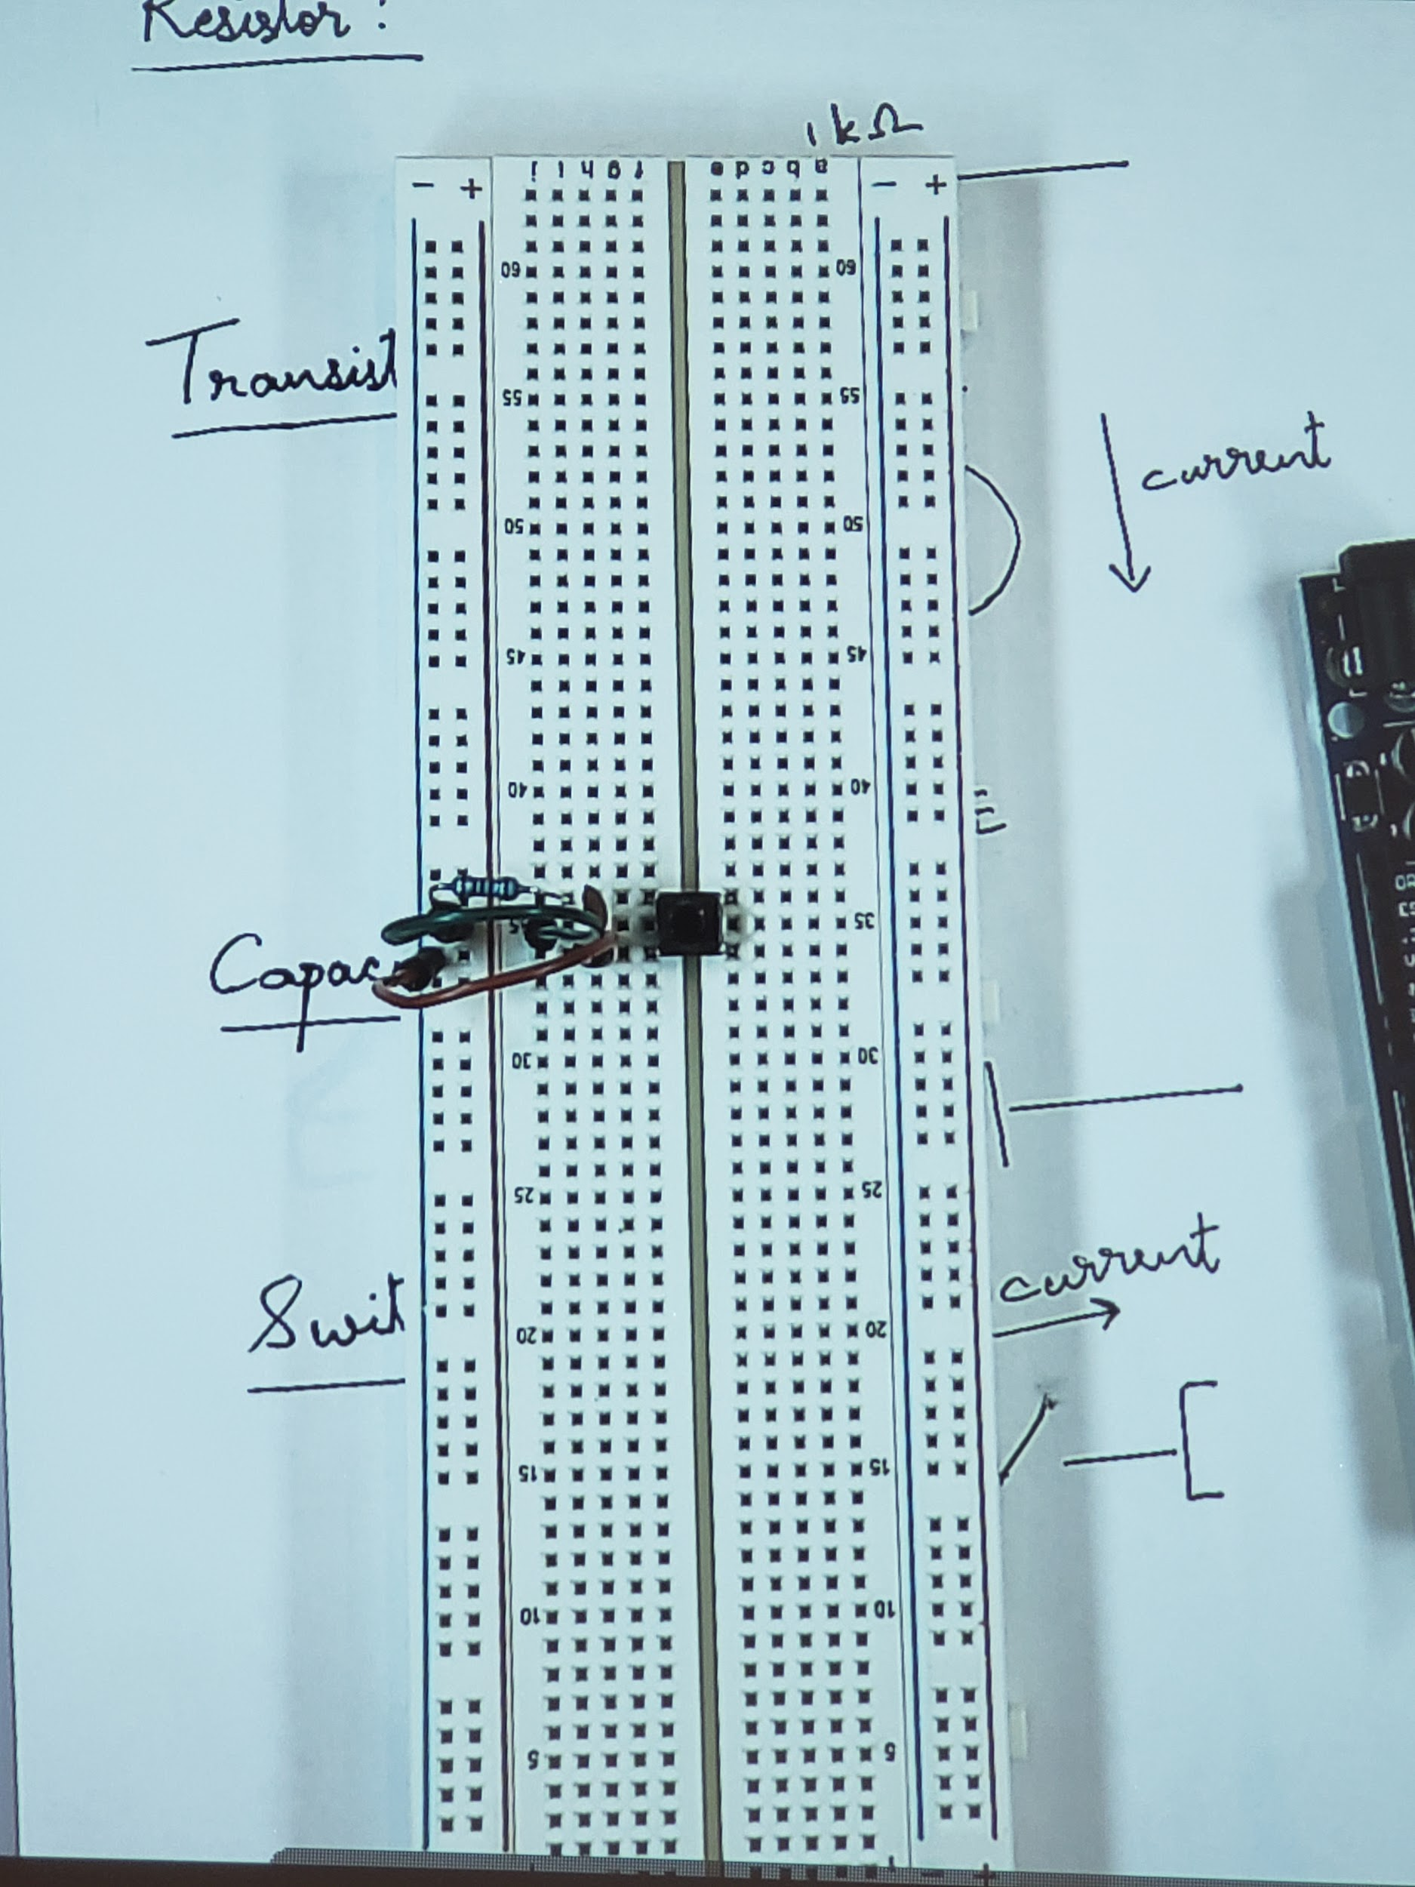
* 5V (blue wire) and Ground (yellow wire) from Arduino is connected to BreadBoard (Opposite of what the board says on the top)
  + 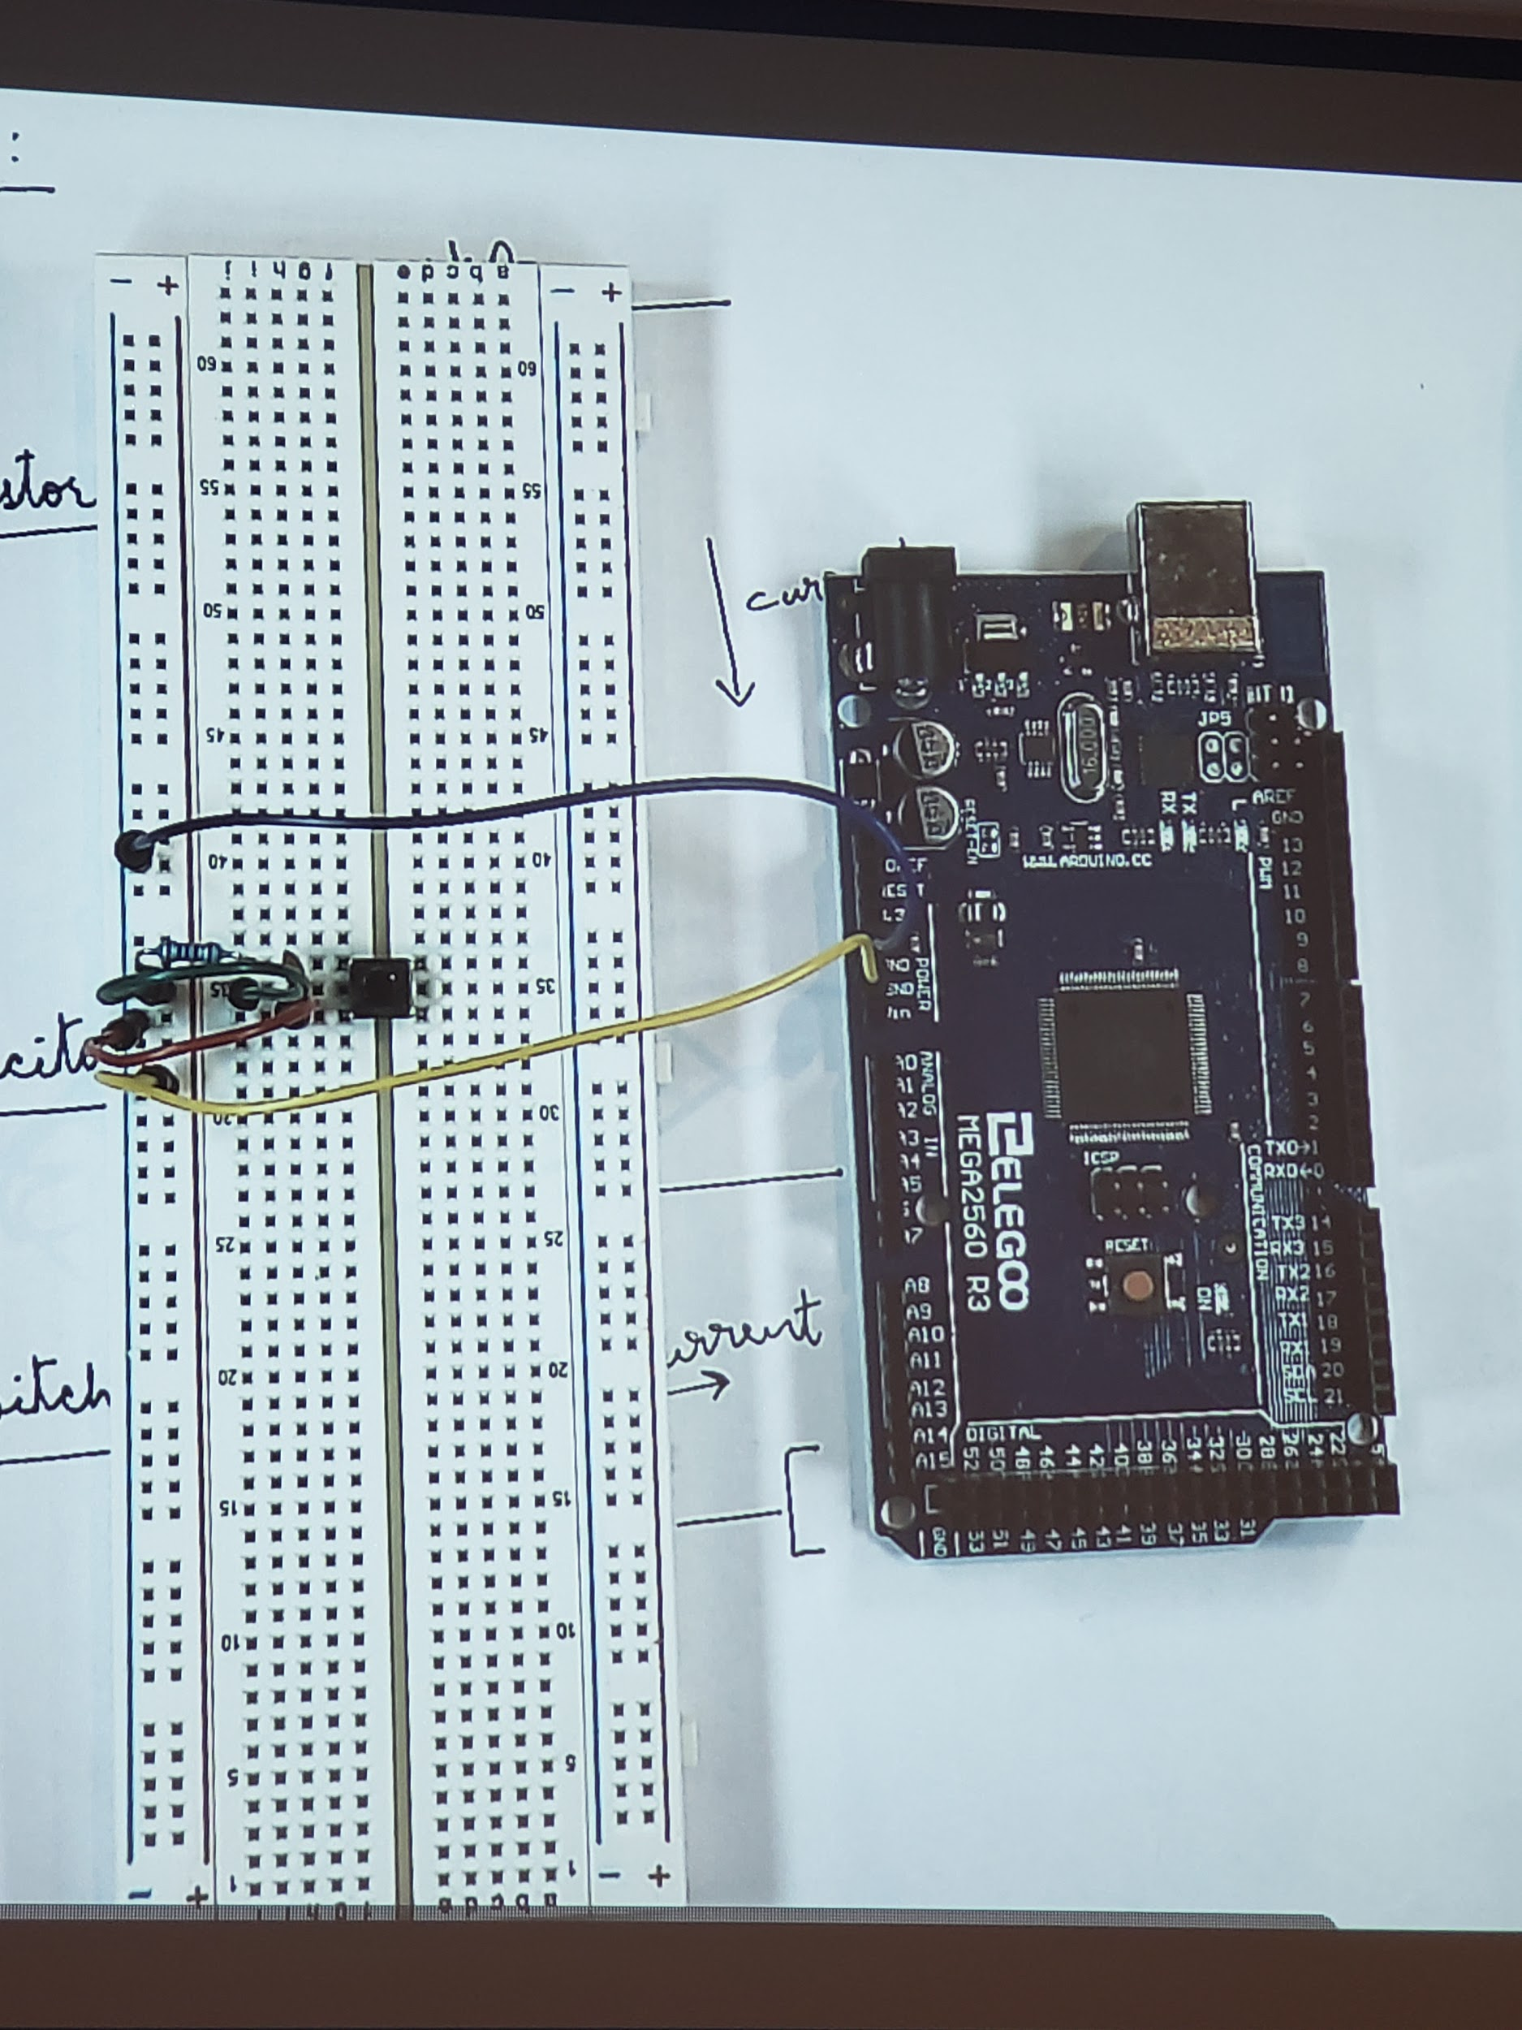
* Connect the LED to Ground
  + 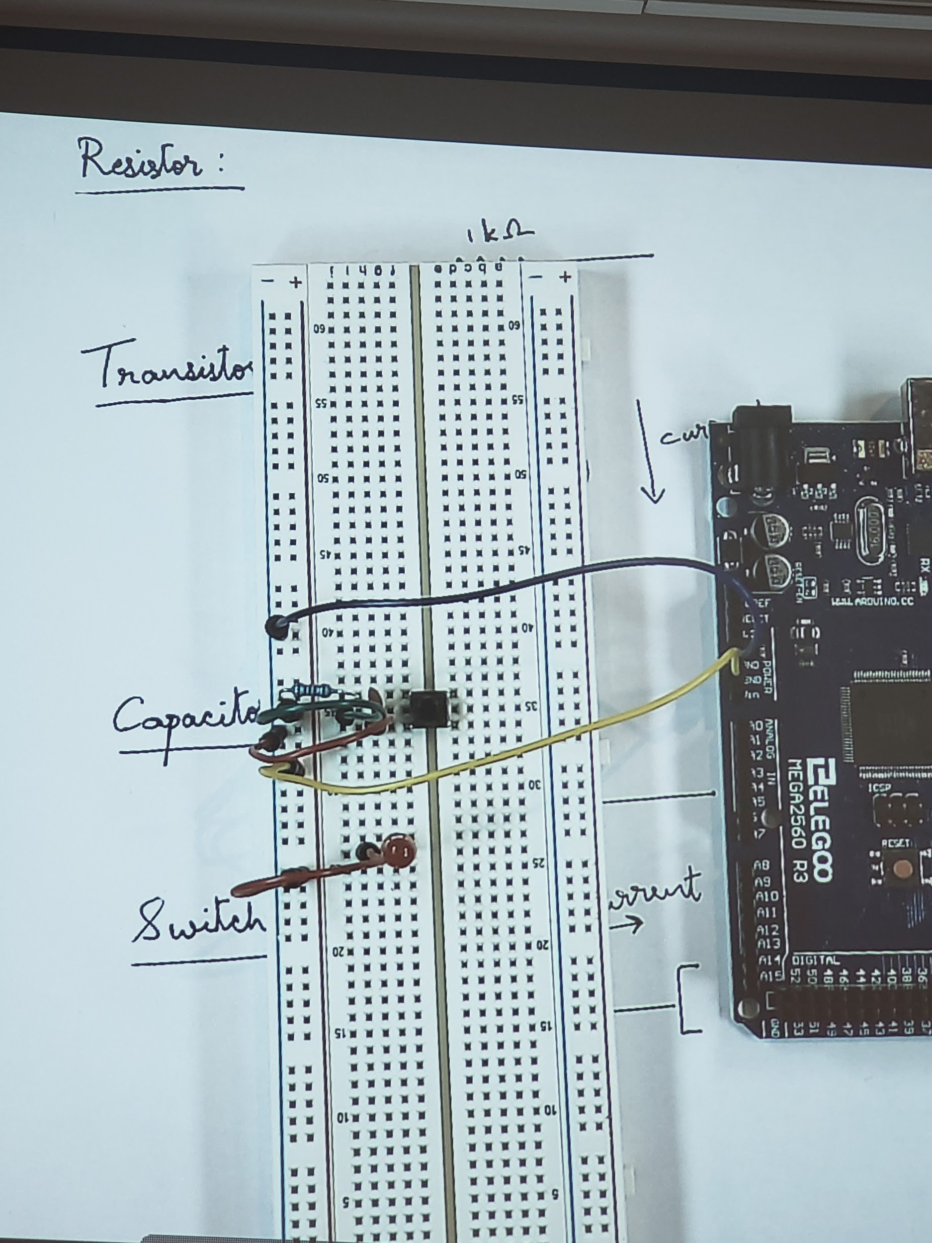
* Connect the 1k Ohm Resistance in series with the LED
  + 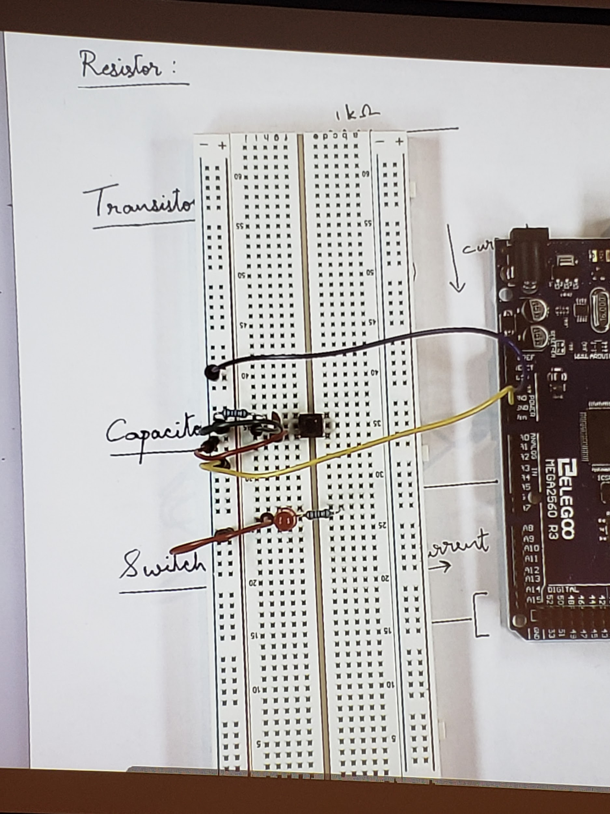
* Connect LED to pin 12
  + 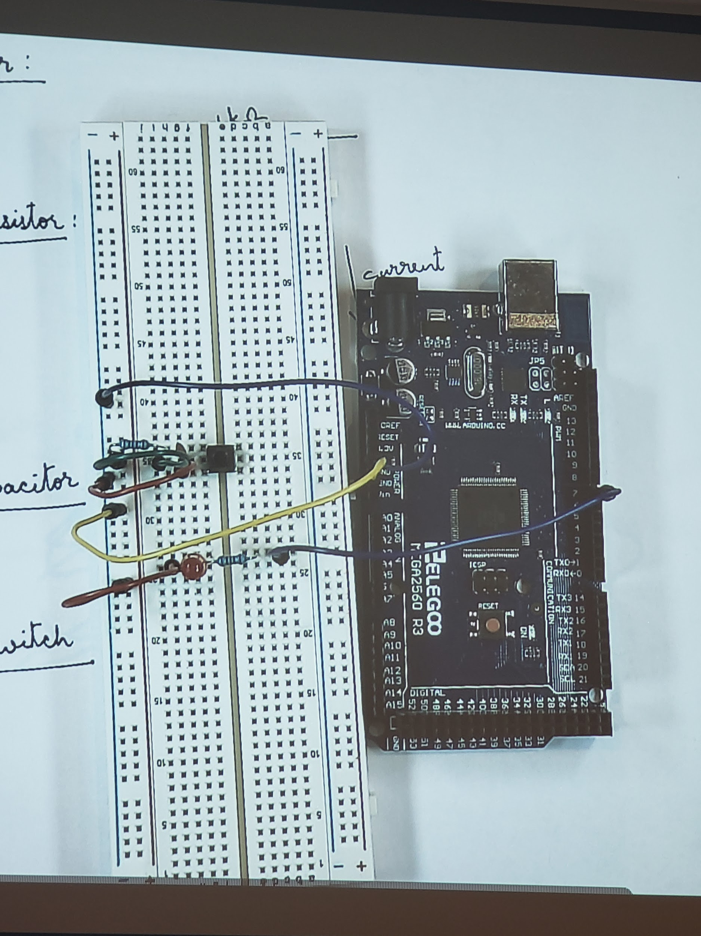
* Connect the Switch to Pin 7
  + 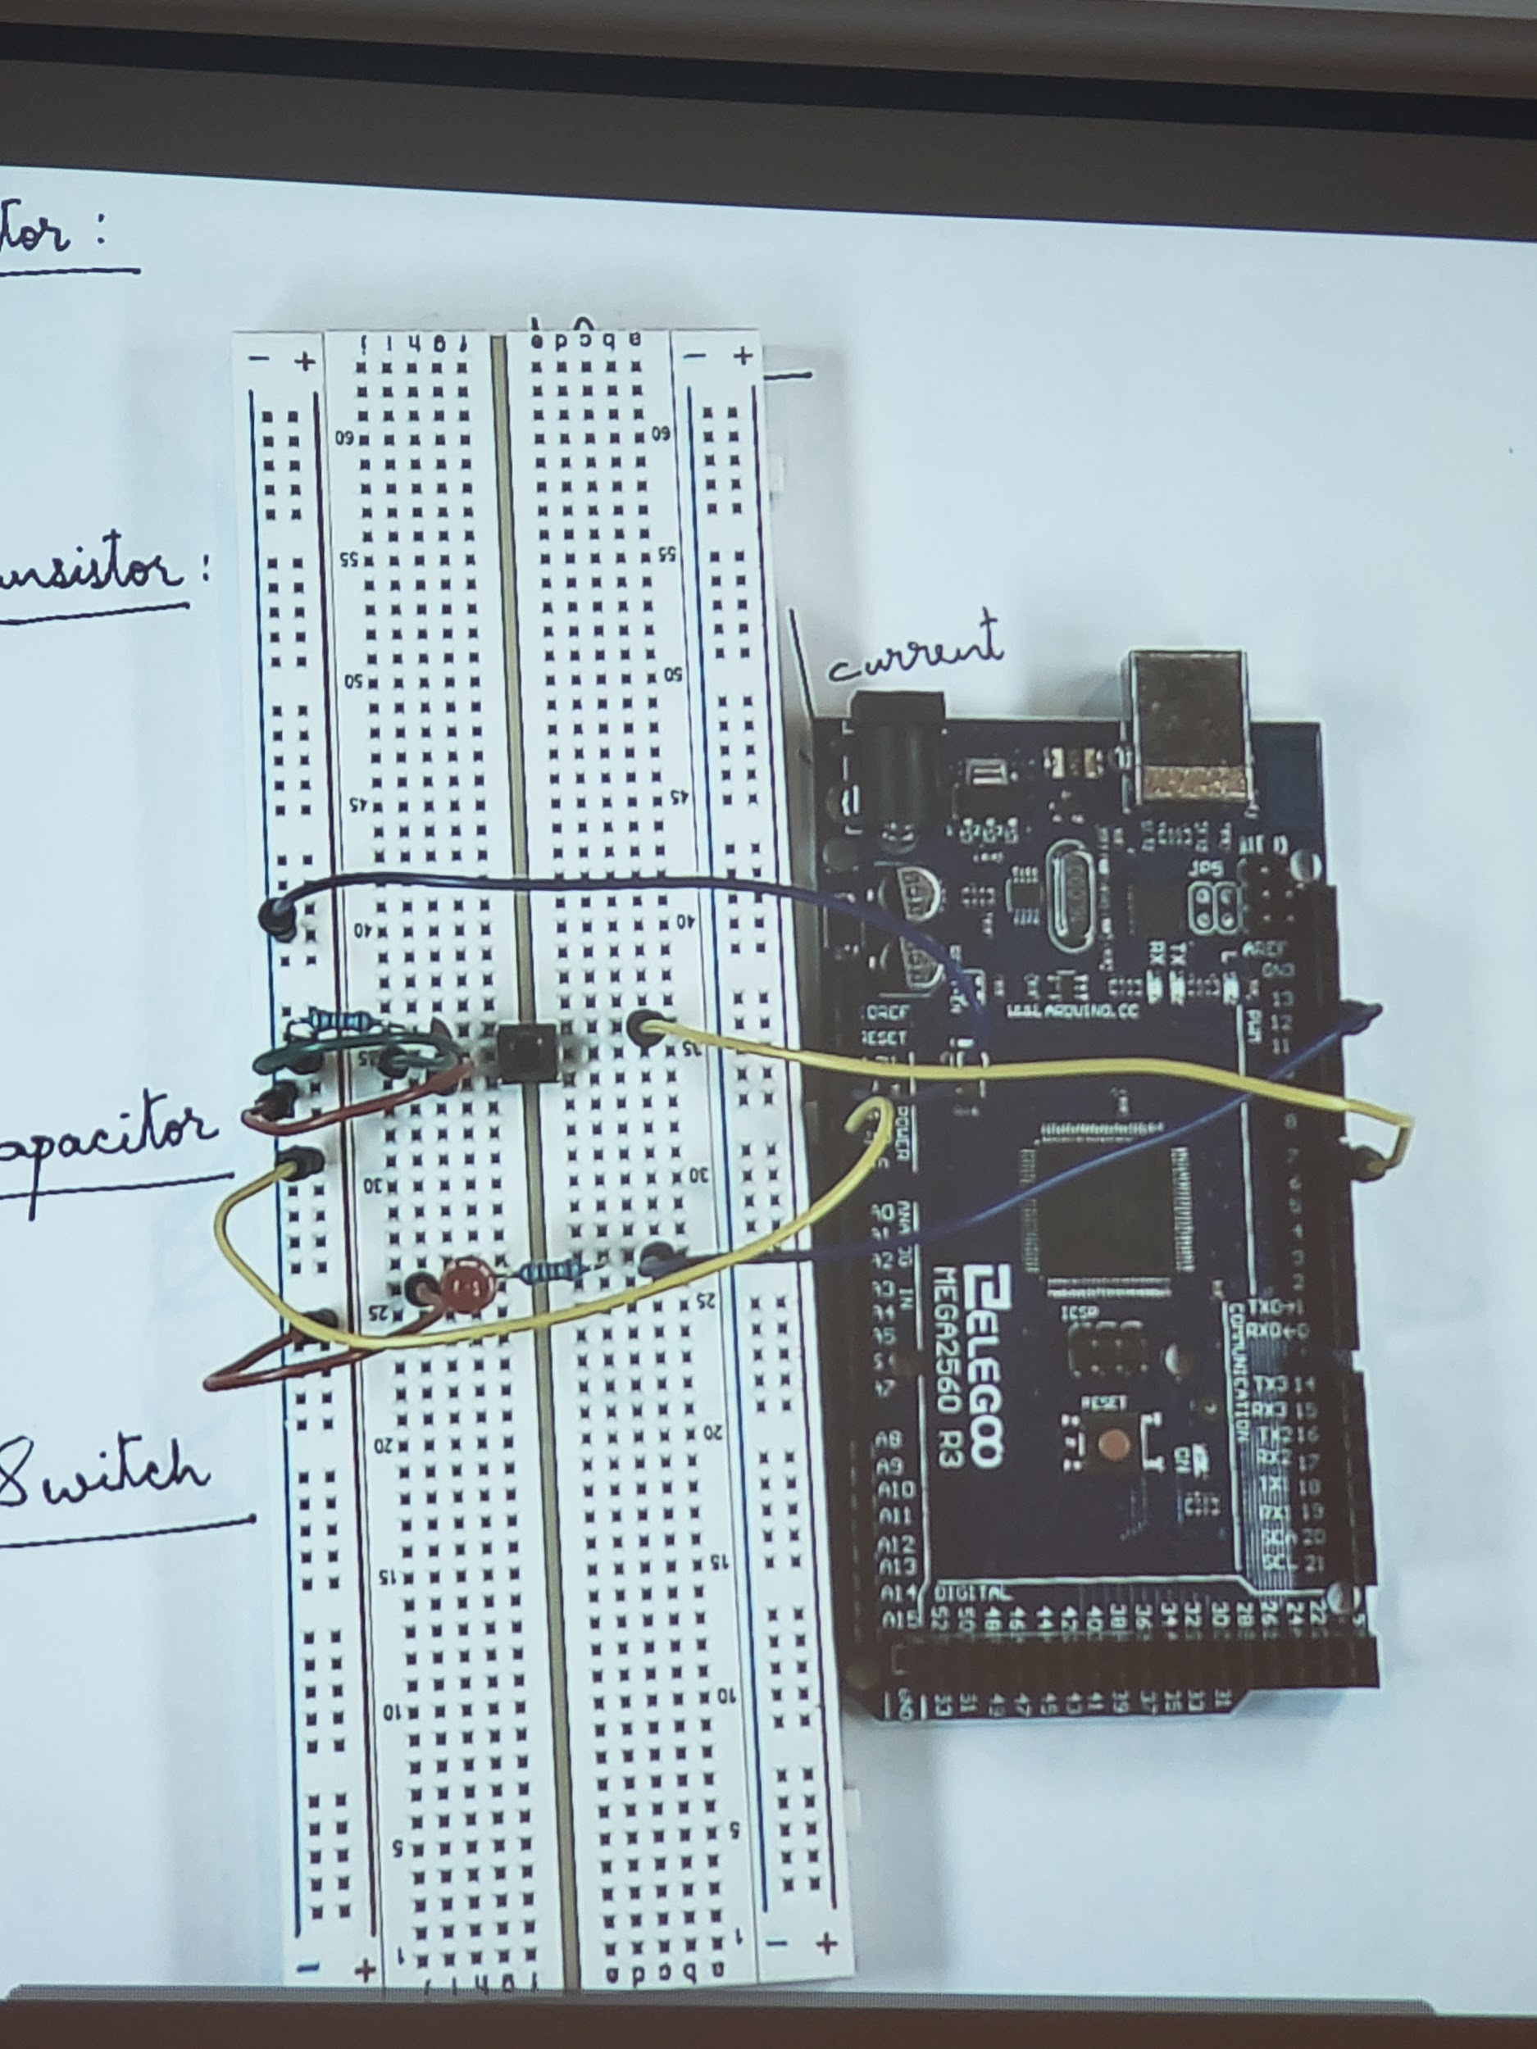
* Code for the Circuit
  + Set LED to OUTPUT
  + Set Button to INPUT
  + In the loop
    - If the button is high (pressed)
      * Set the LED for High, delay for 500 (.5s) then set it back to low
* Behavior of the Code/Circuit
  + Press the button
  + The LED lights up for 0.5sec
  + The LED turns off